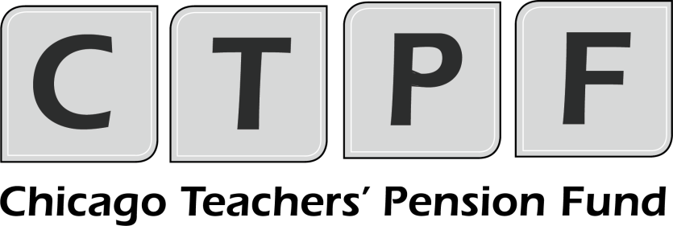
Questions and Answers #1 Related to the RFP for
INVESTMENT CONSULTANT SERVICES
- When was the Fund’s last asset liability study and asset allocation study? How frequently do you expect to receive Asset Liability Studies?

Answer: The last full asset liability study was completed in 2020. There have been two updates of the study in 2022 and 2023 as part of the target asset allocation and asset class reviews. Per the guidelines outlined in CTPF’s Investment Policy Statement, full asset liability studies are conducted every 3-5 years.

- Is there any outstanding legislation that will impact the Fund’s statutory contributions from CPS? If yes please explain the impact.

Answer: As of the last legislative cycle, there is no outstanding legislation that will impact the Fund’s statutory contributions from CPS.

- In addition to the fossil fuel divestment goal highlighted in the Fund’s strategic plan, are there any other potential ESG, DEI goals that a new consultant would be task with helping the Fund achieve?

Answer: Yes. The Board recently approved a Chicago Community Development Strategy focused on providing affordable housing to CTPF’s members. In addition to affordable housing, CTPF is seeking to build and grow neighborhoods in the South and West side of Chicago via community enhancing features such as grocery and retail.
- What is the anticipated number of manager searches per year?

Answer: In the past five years, manager searches have ranged from 1-3x annually.

- When was the last custodial search undertaken, and do you anticipate conducting another in the next 5 years?

Answer: The last custodial search took place in 2013, and CTPF anticipates conducting another search within the next five years.

- Will CTPF consider hiring more than one consultant for this mandate? If so, should consultants consider proposing multiple service packages and fee structures in their response?

Answer: CTPF is looking to hire one general consultant to oversee the entire CTPF portfolio for the next five-year period.

- Please clarify the below boiler plate language in the RFP regarding performance reporting requirements:
- Consultant must “calculate investment performance (net and gross of fees) at the total fund (if applicable), asset class, investment style, and adviser levels.”

Answer: The consultant must calculate, compile, and summarize performance figures (net and gross of fees) for the total fund, each asset class, and individual managers on a monthly and quarterly basis. This process should also include the returns of relevant market indices.

- Please clarify in what instances total fund performance would not be applicable.

Answer: Total fund performance is always applicable.

- How many public manager searches have been conducted over the past 3 years?

Answer: Over the past three years, CTPF has conducted a total of three public manager searches.

- How does the scope of services outlined in the current RFP differ from the current consultant scope of services?

Answer: Currently, CTPF has a single consultant that provides general and real asset consultant services. CTPF is seeking to expand investment consultant services to include the private credit and private equity asset classes

- Can you please provide a copy of your latest asset liability study?

Answer: Yes, please see attached.

- Do you contemplate any changes to the current structure of your investment program?

Answer: CTPF is amid a search for a climate transition index provider. The goal is to offset (on an economic exposure basis) the Fund’s coal, oil and gas holdings within its publicly traded portfolio. The search is projected to be completed by the first half of 2026. A rebalancing is now underway to reserve the funds for this mandate.

- What is the frequency for updating commitment pacing models?

Answer: Pacing models are updated annually.

- How many private commitments do you make each year by asset class?

Answer: Private commitments can vary annually, largely dependent on the pacing model for the asset class. On average, CTPF makes about 2 to 3 commitments per asset class each year, with each commitment typically ranging from $10M to $30M.

- How does the Board, staff and its investment consultant engage with private markets separate account and fund of funds managers?

Answer: Private equity mandates are sourced directly by Fund staff. Going forward, CTPF will require sourcing and due diligence assistance from the general consultant on private equity.

Fund-of-funds managers are treated like regular mandates.

- What is the approval process for new private markets commitments?

Answer: New private market commitments require a competitive Request for Proposal (RFP) search process. Proposals are evaluated by staff and finalists are presented to the Investment Committee for final approval.

We encourage all potential respondents to visit our website at www.ctpf.org to review the Fund’s procurement policy for Investment Advisers.

- What is the approval process for re-ups for private managers currently in the portfolio?

Answer: The annual pacing plan identifies the aggregate proposed commitment along with proposed re-up investment opportunities. Closer to the commitment period, every private market re-up (or re-investment) proposal must then be presented to the Investment Committee for final approval.

